30-1 IPv6 Configuration

- Lab Exercise

In this lab you will configure IPv6 addressing and static routing for a small campus network. The company already has IPv4 configured on their existing network but they will be introducing a new IPv6 application soon. Your task is to configure the network to be dual stack by adding support for IPv6 addresses.
IPv6 routing will be configured in the next lab exercise.

Routers R1, R2 and R3 have been configured with IPv4 addresses and connectivity has been established with between all networks.

PC1 and PC2 are Cisco IOS routers mimicking end hosts. They have been configured with IPv4 addresses and an IPv4 default static route to their default gateways.

There is no IPv6 configuration on any of the devices.

Lab Topology

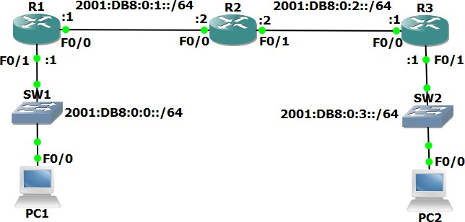

Load the Startup Configurations

Open the ’30-1 IPv6 Addressing.pkt’ file in Packet Tracer to load the lab.

Verify IPv4 Connectivity

- Verify R1, R2, R3, PC1 and PC2 have been configured with IPv4 addresses as shown in the topology diagram.

- View the routing tables on R1, R2 and R3 to verify connectivity has been established between all networks. What routing protocol is being used?

- Verify PC1 and PC2 have been configured with the correct default gateway.

- Ping PC2 from PC1 to verify end to end reachability.

IPv6 Addressing

- Configure global unicast IPv6 addresses on R1, R2, and R3, according to the network topology diagram. Do not enable ipv6 unicast-routing.

- Configure global unicast EUI-64 IPv6 addresses on the FastEthernet 0/0 interfaces on PC1 and PC2.

- Will the routers have IPv6 link local addresses on the interfaces where you just configured global unicast addresses? What about the other interfaces? Verify this.

- Note down the EUI-64 global unicast addresses on PC1 and PC2.

- Configure link local addresses on R1, R2 and R3. For each router, use the address shown below on each of its interfaces.
R1: FE80::1/64 R2: FE80::2/64 R3: FE80::3/64

- Verify the global unicast and link local addresses have been configured correctly on R1, R2 and R3.

- Ping R1 and R3 on their link local addresses from R2.

- View the IPv6 neighbors known by R2.

Static Routing

- Verify which IPv6 dynamic routing protocols are running on R1, R2 and R3. Do not use the ‘show run’ command.

- Use the ‘show run | include ipv6 route’ command on R1, R2 and R3 to verify if they have been configured with IPv6 static routes.

- Do you expect to see any routes in the IPv6 routing tables? Why or why not? Verify this.

- Do you expect PC1 to be able to ping PC2 on its IPv6 address? Why or why not? Verify this.

- Configure PC1 to use R1 as its IPv6 default gateway.

- Configure PC2 to use R3 as its IPv6 default gateway.

- Verify PC1 and PC2 can ping their default gateways.

- Add a static route on R2 for the 2001:db8::/64 network.

- PC1 has reachability to its default gateway R1, and R2 has a route to the 2001:db8::/64 network. Do you expect PC1 be able to ping R2 on 2001:db8:0:1::2? Why or why not? Verify this.

- Fix the problem to allow PC1 to ping R2 on 2001:db8:0:1::2. Enter the command which will fix the problem on R1, R2 and R3.

- Verify PC1 can ping R2 on 2001:db8:0:1::2 now.

- Will PC1 be able to ping PC2 by IPv6 address? Why or why not? Verify this.

- Configure static routes to allow reachability between all IPv6 networks.

- Verify the IPv6 routing tables on R1, R2 and R3.

- Verify PC1 can now ping PC2 by its IPv6 address.

